# Aws services by category:

<https://docs.aws.amazon.com/whitepapers/latest/aws-overview/blockchain.html>

# What are all the core concepts like reliability and redundancy to mention in the aws cloud interview ?

# In an AWS cloud interview, especially for roles like solutions architect, cloud engineer, or DevOps, it's important to demonstrate a deep understanding of core cloud computing principles. Here’s a list of key concepts that are crucial to mention:

### 1. Reliability

* **Definition**: Ensures that a system can recover from failures and continue to function correctly.
* **AWS Services**:
  + **Amazon EC2 Auto Scaling**: Automatically adjusts capacity to ensure availability.
  + **Amazon Route 53**: DNS service that provides failover capabilities.
  + **AWS Elastic Load Balancing (ELB)**: Distributes incoming traffic across multiple instances to ensure fault tolerance.
  + **Amazon RDS Multi-AZ**: Provides high availability by automatically failing over to a standby database.
* **Key Points**: Designing systems that are fault-tolerant and can recover from failures without causing significant downtime.

### **2. Redundancy**

* **Definition**: The duplication of critical components or functions to ensure the system remains operational if one part fails.
* **AWS Services**:
  + **AWS Availability Zones (AZs)**: Using multiple AZs within a region for redundancy and high availability.
  + **Amazon S3 Replication**: Data replication across regions for durability.
  + **AWS Elastic Block Store (EBS)**: Snapshots for data protection and redundancy.
  + **RDS Read Replicas**: To enhance read performance and provide redundancy.
* **Key Points**: Redundant systems (e.g., multiple servers, backup data, etc.) to maintain availability in the face of failures.

### **3. Scalability**

* **Definition**: The ability of a system to handle increased load by adding resources (horizontal or vertical scaling).
* **AWS Services**:
  + **Amazon EC2 Auto Scaling**: Scales EC2 instances based on demand.
  + **AWS Lambda**: Automatically scales based on the number of requests.
  + **Elastic Load Balancer (ELB)**: Scales incoming traffic across multiple instances.
* **Key Points**: Building systems that can handle increased load automatically and efficiently.

### 4. Elasticity

* **Definition**: The ability to dynamically allocate and deallocate resources to match the workload in real time.
* **AWS Services**:
  + **Amazon EC2 Auto Scaling**: Automatically adjusts capacity based on traffic.
  + **AWS Lambda**: Scales automatically to meet demand.
  + **Amazon Elastic File System (EFS)**: Scalable, elastic file storage.
* **Key Points**: Systems should be able to expand or contract resource usage automatically without manual intervention.

### **5. Security**

* **Definition**: Protecting systems and data from unauthorized access and attacks.
* **AWS Services**:
  + **AWS IAM (Identity and Access Management)**: Manages user permissions and access to resources.
  + **AWS Shield**: DDoS protection.
  + **AWS WAF (Web Application Firewall)**: Protects web applications from common exploits.
  + **VPC Security Groups and Network ACLs**: Controls inbound and outbound traffic at the network level.
* **Key Points**: Implementing secure practices like least privilege, encryption, and network segmentation.

### **6. Cost Optimization**

* **Definition**: Managing cloud resources efficiently to avoid unnecessary spending.
* **AWS Services**:
  + **AWS Cost Explorer**: Helps monitor usage and forecast costs.
  + **AWS Reserved Instances and Savings Plans**: Long-term cost-saving strategies.
  + **Amazon EC2 Spot Instances**: Leverage unused EC2 capacity at a lower price.
* **Key Points**: Designing solutions that are cost-efficient while still meeting performance requirements.

### **7. Performance Efficiency**

* **Definition**: The ability to use cloud resources in the most effective way to meet performance requirements.
* **AWS Services**:
  + **Amazon CloudFront**: Content Delivery Network (CDN) for faster delivery of static and dynamic content.
  + **AWS Elasticache**: In-memory caching to improve performance.
  + **Amazon S3 for Storage Optimization**: Choosing the right storage class for your use case.
* **Key Points**: Optimizing systems for both speed and responsiveness.

### **8. Governance, Risk, and Compliance (GRC)**

* **Definition**: Frameworks, policies, and procedures to ensure cloud solutions adhere to legal, regulatory, and internal requirements.
* **AWS Services**:
  + **AWS CloudTrail**: Tracks user activity and API usage for auditing purposes.
  + **AWS Config**: Helps with compliance auditing and change tracking.
  + **AWS Artifact**: Access to compliance reports and certifications.
* **Key Points**: Understanding regulatory requirements, ensuring data privacy, and adhering to compliance standards.

### **9. Disaster Recovery (DR)**

* **Definition**: Strategies to quickly restore IT services after a disaster.
* **AWS Services**:
  + **Amazon RDS Multi-AZ**: For automated failover and data redundancy.
  + **Amazon S3 Glacier**: Low-cost archival storage for backups.
  + **AWS Backup**: Centralized backup management across AWS services.
* **Key Points**: Implementing backup and restore processes, failover mechanisms, and data durability.

### **10. Infrastructure as Code (IaC)**

* **Definition**: Managing and provisioning cloud resources using machine-readable configuration files rather than manual processes.
* **AWS Services**:
  + **AWS CloudFormation**: Automates the provisioning of AWS infrastructure using code.
  + **AWS CDK (Cloud Development Kit)**: A higher-level IaC framework for defining cloud resources in code.
* **Key Points**: Version-controlling infrastructure, reducing human error, and enabling repeatable deployments.

### **11. Containers and Orchestration**

* **Definition**: Using containers for efficient application deployment and scaling.
* **AWS Services**:
  + **Amazon ECS (Elastic Container Service)**: Orchestration for Docker containers.
  + **Amazon EKS (Elastic Kubernetes Service)**: Managed Kubernetes service.
  + **AWS Fargate**: Serverless compute engine for containers.
* **Key Points**: Building microservices architectures, managing containerized applications at scale.

### **12. Microservices Architecture**

* **Definition**: A software architecture style that structures an application as a collection of loosely coupled, independently deployable services.
* **AWS Services**:
  + **AWS Lambda**: Run code in response to events without managing servers.
  + **Amazon API Gateway**: Manage and deploy APIs.
  + **Amazon SQS/SNS**: Messaging services for inter-service communication.
* **Key Points**: Designing decoupled, independently scalable services to improve resilience and agility.

### **13. Serverless Computing**

* **Definition**: Running applications without managing servers, allowing developers to focus on writing code.
* **AWS Services**:
  + **AWS Lambda**: Run code in response to triggers without provisioning servers.
  + **Amazon API Gateway**: Expose HTTP endpoints for Lambda functions.
  + **Amazon DynamoDB**: Serverless NoSQL database.
* **Key Points**: Cost-effective, scalable, and highly available architecture where you only pay for usage.

### **14. Edge Computing and Content Delivery**

* **Definition**: Moving computation closer to data sources to reduce latency.
* **AWS Services**:
  + **Amazon CloudFront**: CDN to deliver content with low latency.
  + **AWS Outposts**: Run AWS services on-premises for hybrid cloud solutions.
* **Key Points**: Reducing latency by processing data closer to users, especially for IoT and high-performance applications.

### **15. Logging, Monitoring, and Observability**

* **Definition**: Tools and practices to track, monitor, and analyze cloud application performance and health.
* **AWS Services**:
  + **Amazon CloudWatch**: Monitoring and observability service.
  + **AWS X-Ray**: Helps analyze and debug distributed applications.
  + **AWS CloudTrail**: Logs API calls and user activity.
* **Key Points**: Enabling continuous monitoring, real-time alerts, and troubleshooting capabilities.

# 

### **Key Concepts to Emphasize:**

* **Shared Responsibility Model**: Clarifying the division of security responsibilities between AWS and the customer.
* **Regions and Availability Zones**: Understanding AWS's global infrastructure and how to architect for high availability.
* **Well-Architected Framework**: Focusing on the five pillars: Operational Excellence, Security, Reliability, Performance Efficiency, and Cost Optimization.

### **Interview Tip:**

# For each concept, try to relate it to a real-world scenario or AWS service. This helps demonstrate practical experience in using AWS services for solving complex problems.

# 

# Aws region, AZ, local zone, edge location

# Aws cli, aws sdk, cdk, boto3

# When to use sdk and cdk ?

**Vpc:**

# Migration of landing zone to Control tower:

<https://docs.aws.amazon.com/controltower/latest/userguide/cfct-overview.html>

<https://docs.aws.amazon.com/controltower/latest/userguide/customize-landing-zone.html>

<https://aws.amazon.com/controltower/faqs/>

"If you have customized the AVM CloudFormation template for creating accounts (For example chaining within same service catalog product or customization related directly within account vending resource), then you might want to keep the existing AWS Service Catalog Product as well as the Provisioned product. You must update the section that trigger account provisioning with a new one for Control Tower Account Factory for example:"

<https://docs.google.com/spreadsheets/d/1Y_QCqhAkVBBsG_4yMF2pa2G9kjXKGGWdiSMiJ2jcEQ8/edit#gid=1654051064>

<https://aws.amazon.com/premiumsupport/programs/iem/>

# Aws service catalog:

<https://aws.amazon.com/blogs/mt/visualize-aws-service-catalog-product-usage-in-an-aws-organization-with-amazon-quicksight/>

Setup the service catalog delegate account

Create the portfolios and products

Share the portfolios and products to Organization

# Aws kms:

**symmetric** - SYMMETRIC_DEFAULT (AES-256-GCM) - encryption key - encryption and decryption with same key

HMAC keys (symmetric) - HMAC_224,HMAC_256,HMAC_384,HMAC_512

**asymmetric** - RSA_2048,RSA_3072,RSA_4096 - encryption with private key and decrypt with public key.

cloudhsm -

**Enable key rotation** - only supports symmetric key, if we enable rotation it will create rotation key after a year.

**Cloudhsm:** <https://github.com/aws-samples/aws-cloudhsm-cloudformation-template>

https://www.yobyot.com/aws/aws-kms-multi-region-keys/2022/07/12/

# **Aws quick sight dashboard for CUR:** cost and utilization report

# **Aws cost allocation tags:** aws added, customer added, which will give the cost of individual accounts once it enabled.

https://docs.aws.amazon.com/awsaccountbilling/latest/aboutv2/activate-built-in-tags.html

Adding tags to resources in individual accounts and enabling cost allocation tags in payer will replace the tags or can enforce the tags on resources once they are created.

# Explore of cost explorer:

https://aws.amazon.com/blogs/aws-cloud-financial-management/tips-and-tricks-for-exploring-your-data-in-aws-cost-explorer-part-2/

**Tag automation:**

1. **List tagging supported services in aws**
2. **At the time of account creation, store 6 tag key values in aws ssm parameter store.**
3. **Once a resource get created, cloudtrail will invoke aws event bridge which will invoke aws lambda to read the values from ssm parameter store and**

**Tagging implementation with cost allocation tags activation and viewing the billing on cost explorer - https://aws.amazon.com/blogs/aws-cloud-financial-management/gs-create-and-enforce-your-tagging-strategy-for-more-granular-cost-visibility/**

**Tagging best practices:** [**https://youtu.be/g7KiVz95wjo?si=8xVmf2L-9KvlzU2C**](https://youtu.be/g7KiVz95wjo?si=8xVmf2L-9KvlzU2C)

**Cost allocation strategy:**

[**https://youtu.be/Xh_q03P_xvw?si=ewhCnXCjgw9dsywQ**](https://youtu.be/Xh_q03P_xvw?si=ewhCnXCjgw9dsywQ)

**Cost categories:**

[**https://youtu.be/Tc18eNy7uCg?si=ofHLgfbJE_5ZNaWl**](https://youtu.be/Tc18eNy7uCg?si=ofHLgfbJE_5ZNaWl)

**Cost explorer cost for marketplace:** [**https://aws.amazon.com/blogs/aws-cloud-financial-management/monitoring-your-aws-marketplace-costs-and-usage/**](https://aws.amazon.com/blogs/aws-cloud-financial-management/monitoring-your-aws-marketplace-costs-and-usage/)

**In cost explorer choose the Billing entity as AWS Marketplace and in groupby filter choose the service. Which will show the cost per month for marketplace subscriptions.**

# Tags advantages of tagging:

**Automation**

**Patching**

**Cost and usage report**

**Data classification**

**Explorer and cur**

**Diff tags and cost allocation tags:**

**Cost categories: will help to divide the cost by teams or business units or by application names**

**Cost per service ?**

**Charge by account ?**

**You have to enable cost explorer from payer if you use organization ?**

**If not if it’s single account can we enable it for free in single accounts ?**

**Filter cost in cost explorer with cost categories?**

**Filter the cost explorer by teams and projects ?**

**Use tag editor to find the untagged resources?**

**Tagging white paper ?**

**Cost category splitting?**

# List of tagging supported services:

**https://docs.aws.amazon.com/resourcegroupstagging/latest/APIReference/supported-services.html**

**Event Bridge Rule:**

**{**

**"source": ["aws.ec2", "aws.s3", "aws.eks", "aws.lambda", "aws.efs", "aws.rds", "aws.kms", "aws.cloudwatch", "aws.eventbridge", "aws.apigateway", "aws.sqs", "aws.sns", "aws.es", "aws.elasticcache", "aws.route53", "aws.iam", "aws.stepfuntions", "aws.athena", "aws.glue", "aws.emr", "aws.kinesis", "aws.redshift", "aws.cloudfront", "aws.acm", "aws.elasticloadbalancer", "aws.ecs", "aws.cloudtrail", "aws.backup", "aws.aurora", "aws.config", "aws.mq", "aws.secretmanager", "aws.workspaces", "aws.systemsmanager", "aws.swf", "aws.ram", "aws.cloudformation", "aws.fsx", "aws.ecr", "aws.dynamodb", "aws.dlm"],**

**"detail": {**

**"eventName": ["CreateVpcEndpoint", "CreateKey", "CreateRouteTable", "CreateSecurityGroup", "CreateSubnet", "RunInstances", "CreateImage", "CreateVpc", "CreateVolume", "CreateSnapshot", "createLaunchTemplate", "Createkeypair", "CreateBucket", "Createmultipartiupload", "CreateFuntion", "Creatalias", "Createfuntionurlconfig", "Addlayerversionpermission", "Createfilesystem", "Createaccesspoint", "Createmounttarget", "Createreplicationconfiguration", "createaddon", "CreateCluster", "CreateNodegroup", "createfargateprofile", "CreateTrail", "CreateManagedPrefixList", "CreateTransitGateway", "CreateTopic", "CreateQueue", "CreateHostedZone", "CreateRole", "CreatePolicy", "CreateUser", "CreateFunction20150331", "CreateEventBus", "CreateLogGroup", "CreateFileSystem", "CreateStateMachine", "CreateTable", "CreateDBInstance", "CreateDBCluster", "CreateCluster", "CreateStream", "RunJobFlow", "CreateRestApi", "CreateHttpApi", "CreateLoadBalancer", "CreateAutoScalingGroup", "CreateLaunchConfiguration", "CreateApplication", "StartQueryExecution", "CreateJob", "CreateCluster", "RegisterScalableTarget", "CreateDirectConnectGateway", "CreateDirectConnectGatewayAssociation", "CreateDirectConnectGatewayAssociationProposal", "CreateLag", "CreatePrivateVirtualInterface", "CreatePublicVirtualInterface", "CreateTransitVirtualInterface", "CreateDirectConnectGatewayAttachment", "CreateDirectConnectGatewayRoute", "CreateDirectConnectGatewayAssociation", "CreateApiKey", "CreateDomainName", "CreateRestApi", "CreateStage", "CreateVpcLink"]**

**}**

**}**

**{**

**"source": ["aws.ec2", "aws.s3", "aws.eks", "aws.lambda", "aws.efs", "aws.rds", "aws.kms", "aws.cloudwatch", "aws.eventbridge", "aws.apigateway", "aws.sqs", "aws.sns"],**

**"detail": {**

**"eventName": ["CreateVpcEndpoint", "CreateKey", "CreateRouteTable", "CreateSecurityGroup", "CreateSubnet", "RunInstances", "CreateImage", "CreateVpc", "CreateVolume", "CreateSnapshot", "createLaunchTemplate", "Createkeypair", "CreateBucket", "Createmultipartiupload", "CreateFuntion", "Creatalias", "Createfuntionurlconfig", "Addlayerversionpermission", "Createfilesystem", "Createaccesspoint", "Createmounttarget", "Createreplicationconfiguration", "createaddon", "CreateCluster", "CreateNodegroup", "createfargateprofile", "CreateTrail", "CreateManagedPrefixList", "CreateTransitGateway", "CreateTopic", "CreateQueue", "CreateDomainName", "CreateRestApi", "CreateStage", "CreateVpcLink"]**

**}**

**}**

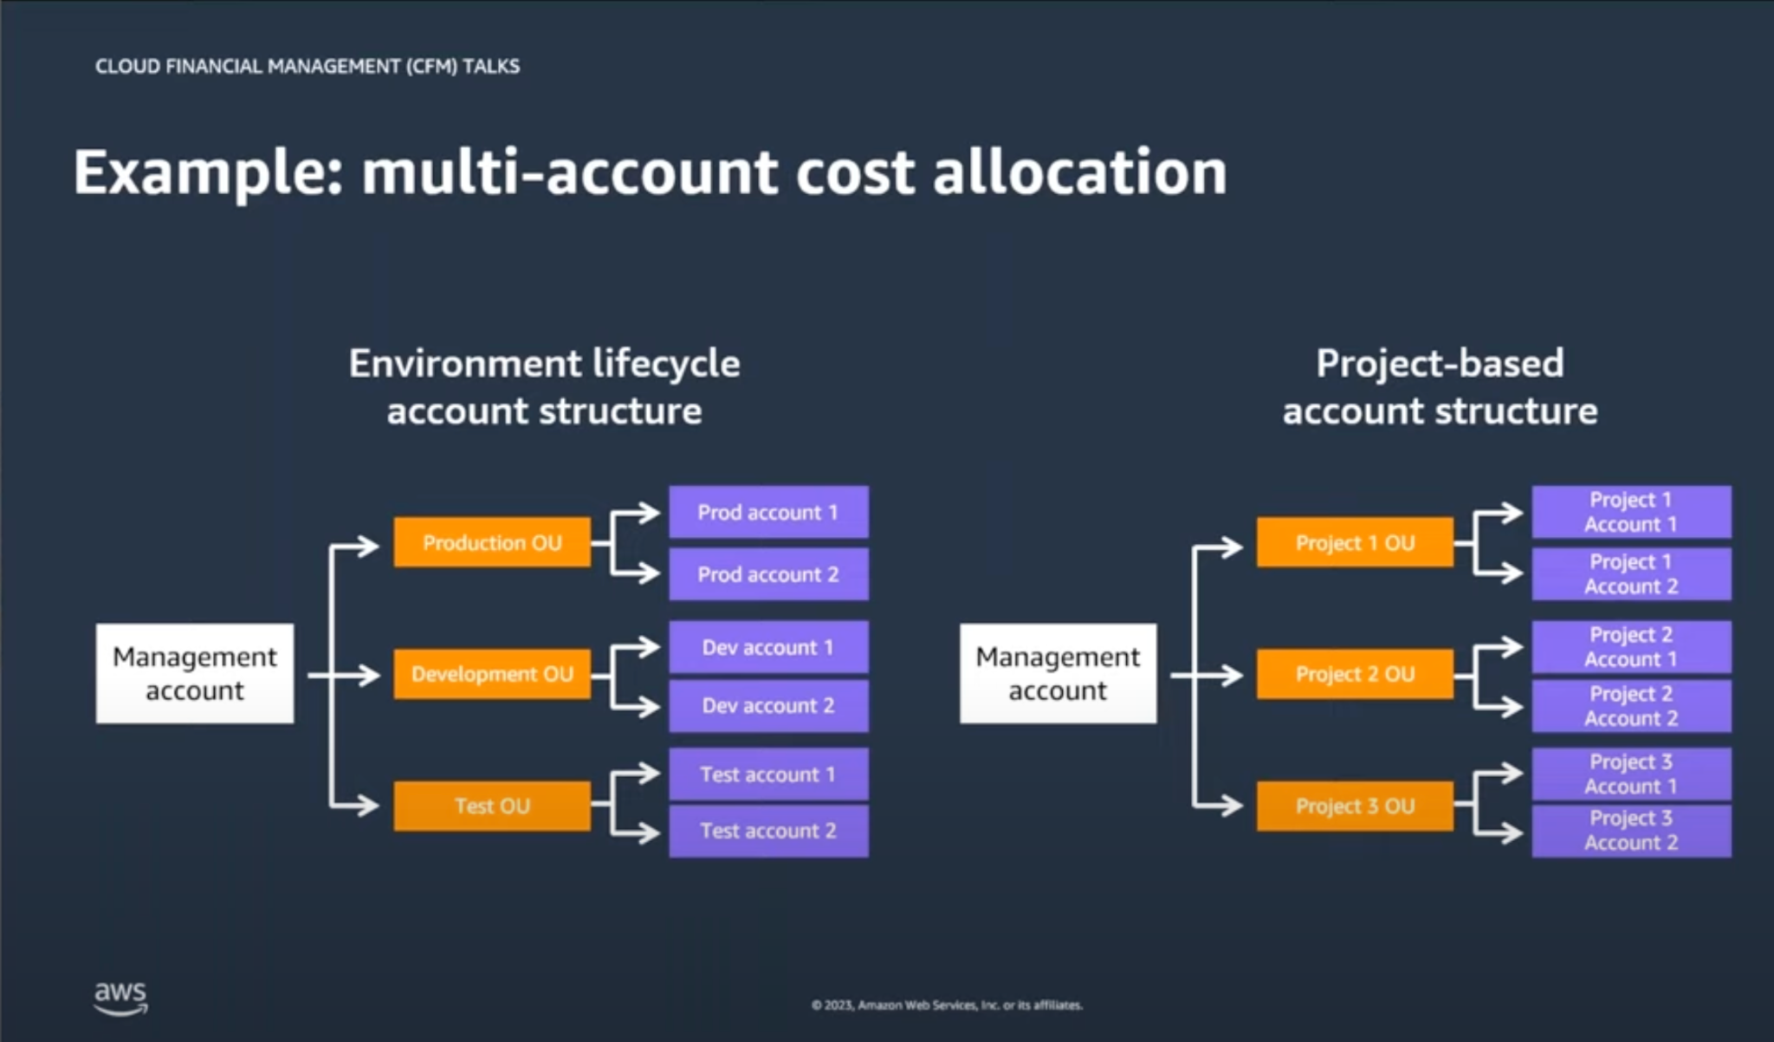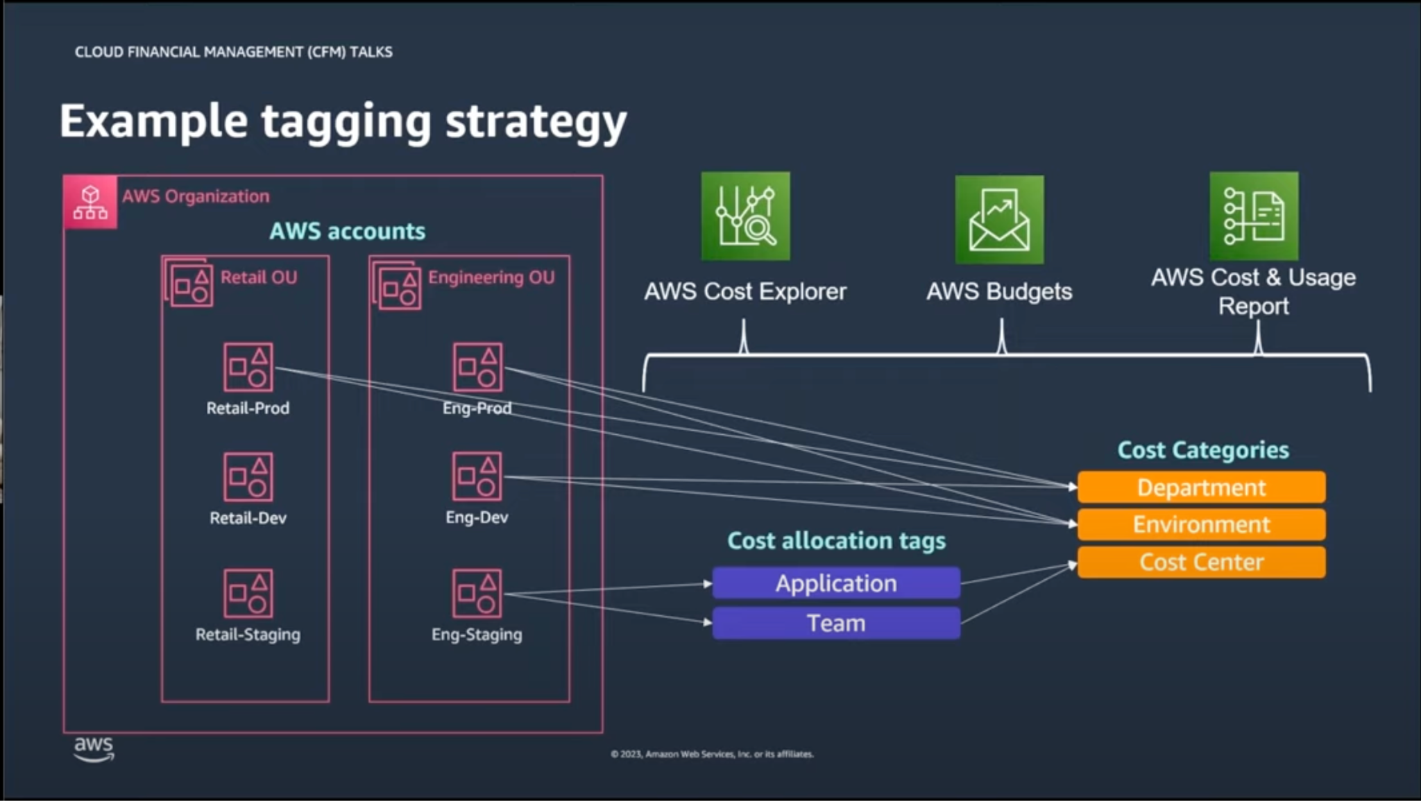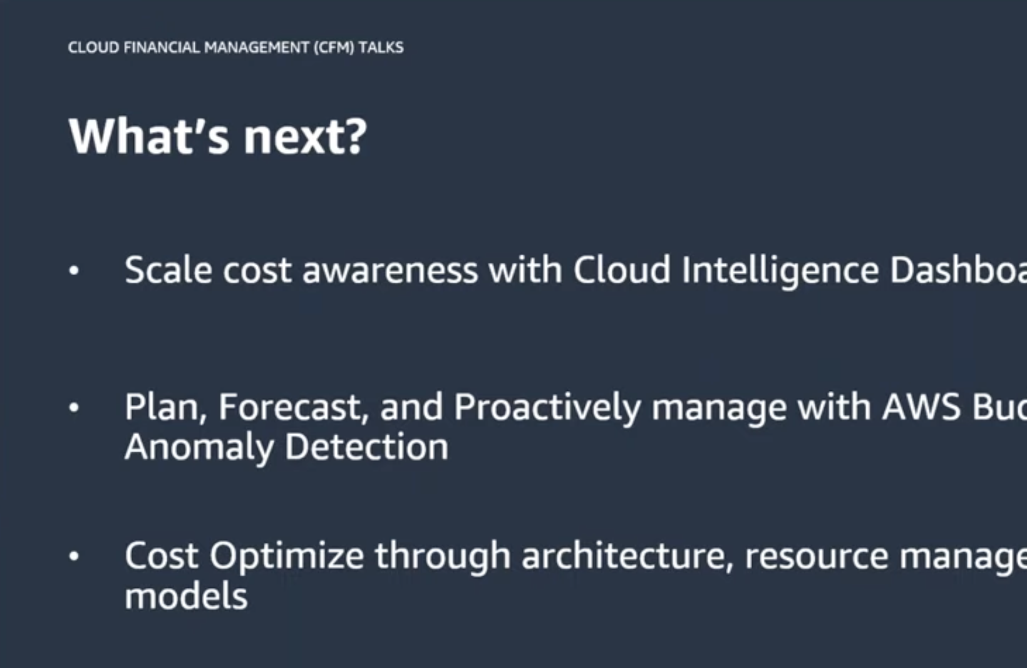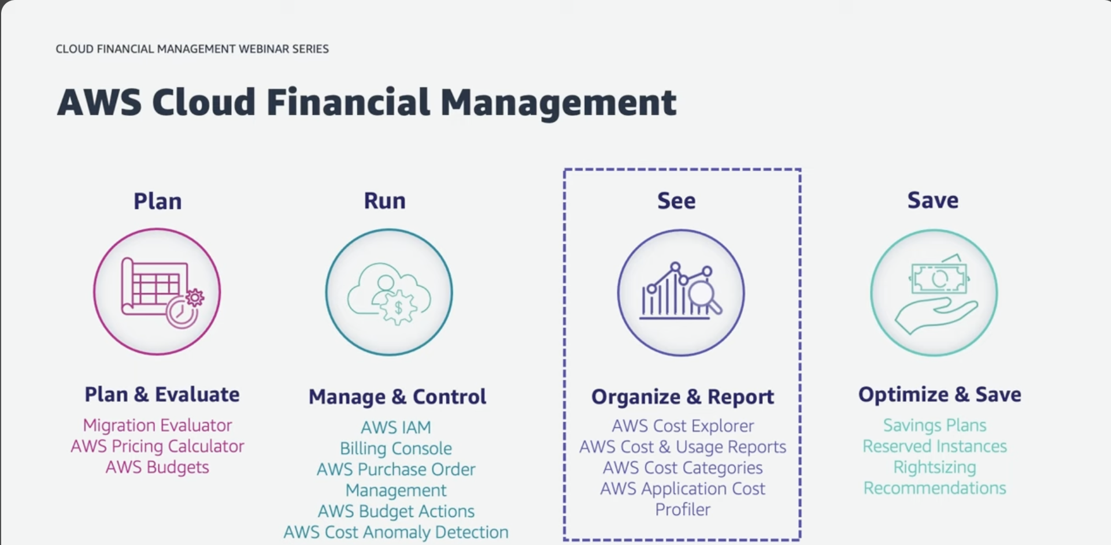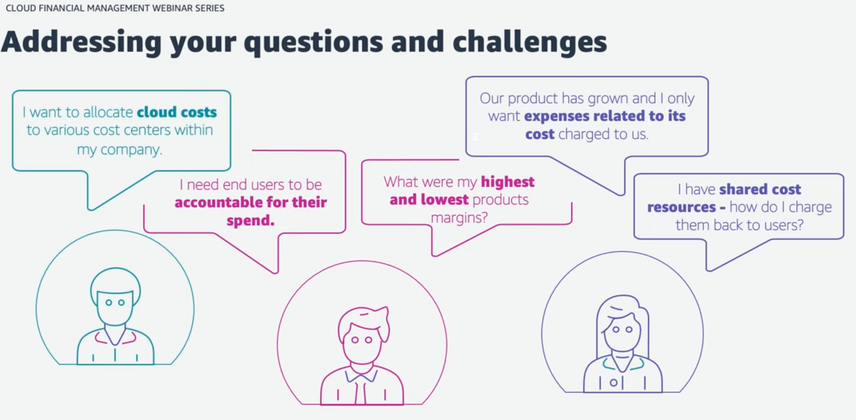

**Aws backup & Multi region kms key:**

Onprem servers backup with aws backup and backup gateway - <https://aws.amazon.com/blogs/storage/backup-and-restore-on-premises-vmware-virtual-machines-using-aws-backup/>

Two permissions needs add on the policy - <https://docs.aws.amazon.com/aws-managed-policy/latest/reference/AWSBackupServiceRolePolicyForS3Restore.html#AWSBackupServiceRolePolicyForS3Restore-json>

S3 bucket versioning and ACL need to be enabled on destination account

Restore to Create new bucket failing in us-east-1 as the scp is blocking

Restore to existing bucket, means restore in DR region works if the bucket has versioning and ACL enabled.

Ec2 restore worked in east-1 but the Member-Account-Backup-Role needs to whitelist in scp.

Create multi region KMS key

In DR, restore DB snapshot with multi region KMS key is pending?

Need to whitelist the role in scp to restore the instances - Member-Account-Backup-Role

Document DB restore in east-1 - <https://aws.amazon.com/blogs/storage/manage-backup-and-restore-of-amazon-documentdb-with-aws-backup/>

* From the console document db expect the default vpc

Document DB restore from cli without Default VPC:

I found a possible workaround. This is the documentation on creating a clone for documentDB:

https://docs.aws.amazon.com/documentdb/latest/developerguide/db-cluster-cloning.html#db-creating-db-clone

To create a clone with the CLI you can see the following example command:

aws docdb restore-db-cluster-to-point-in-time \

--db-cluster-identifier hermod-email-service-api-clone-test \

--restore-type copy-on-write \

--source-db-cluster-identifier hermod-email-service-api \

--kms-key-id <kmsID> \

--use-latest-restorable-time \

--port <port> \

--vpc-security-group-ids <sg-group> \

--db-subnet-group-name <subnet> \

--no-deletion-protection

Aurora postgres restore - success - [B1785F16-5EC9-5FE0-A611-956074889D0C](https://us-east-1.console.aws.amazon.com/backup/home?region=us-east-1#jobs/restore/B1785F16-5EC9-5FE0-A611-956074889D0C) -

|  |
| --- |

Vault lock enabled ?

Backup vault policy:

{

"Version": "2012-10-17",

"Statement": [

{

"Sid": "VisualEditor0",

"Effect": "Allow",

"Principal": {

"AWS": "arn:aws:iam::839108559729:role/aws-reserved/sso.amazonaws.com/us-west-2/AWSReservedSSO_Dish-AwsSSO-Administrator_76c69dff79af398a"

},

"Action": [

"backup:DescribeBackupVault",

"backup:DeleteBackupVault",

"backup:PutBackupVaultAccessPolicy",

"backup:DeleteBackupVaultAccessPolicy",

"backup:GetBackupVaultAccessPolicy",

"backup:GetBackupVaultNotifications",

"backup:PutBackupVaultNotifications",

"backup:DeleteBackupVaultNotifications",

"backup:ListRecoveryPointsByBackupVault",

"backup:DeleteRecoveryPoint",

"backup:UpdateRecoveryPointLifecycle",

"backup:DescribeRecoveryPoint",

"backup:DeleteRecoveryPoint",

"backup:GetRecoveryPointRestoreMetadata"

],

"Resource": "*"

}

]

}

-------------------------------------------------------------------------------------------------------------------------------

S3 bucket for vpc flow logs need to change in service catalog products in us-east-1.

Delete vpc in us-east-1 in ce-pe-demo-np account

-------------------------------------------------------------------------------------------------------------------------------

aws-glue studio -ETL - [AWS Glue ETL | Hands-On | AWS Glue tutorial | p4](https://www.youtube.com/watch?v=yGeEIp8fBPc)-------------------------------------------------------------------------------------------------------------------------------

AWS EBS snapshots and RDS snapshots clean up with aws DLM:

<https://bluexp.netapp.com/blog/ebs-volumes-5-lesser-known-functions?hs_amp=true>

https://dev.to/paulmicheli/aws-automated-snapshot-cloudformation-1g6cs

<https://dev.to/dineshrathee12/my-1st-aws-knowledge-center-article-published-to-help-customers-amazon-data-lifecycle-manager-1gc0>

<https://repost.aws/knowledge-center/troubleshoot-data-lifecycle-manager-ebs>

<https://dev.to/dineshrathee12/aws-dlm-data-lifecycle-management-snapshots-not-being-created-or-policy-in-error-state-troubleshooting-tips-4lkm>

-------------------------------------------------------------------------------------------------------------------------------

Right size your ec2 instance solution:

<https://docs.aws.amazon.com/whitepapers/latest/cost-optimization-right-sizing/tips-for-right-sizing-your-workloads.html>

<https://pages.awscloud.com/Lower-Costs-by-Right-Sizing-Your-Instance-with-Amazon-EC2-T3-General-Purpose-Burstable-Instances_2019_0923-CMP_OD.html?&trk=el_a131L00000583VsQAI&trkCampaign=September_2019_0923-CMP&sc_channel=el&sc_campaign=pac_Q3-2019_exlinks_blog_OTT_09DGAB&sc_outcome=Product_Adoption_Campaigns&sc_geo=NAMER&sc_country=mult>

-------------------------------------------------------------------------------------------------------------------------------

**PCIDSS - https://aws.amazon.com/solutions/implementations/compliance-pci-fsbp-remediation/**

-------------------------------------------------------------------------------------------------------------------------------

**Aws workspace automation with lambda -**

**Delete the Aws workspace unused workspaces with sqs and lambda -**

**Aws workspace cost optimization -**

**Aws cost allocation tags:**

**Aws backup & Multi region kms key:**

Onprem servers backup with aws backup and backup gateway - <https://aws.amazon.com/blogs/storage/backup-and-restore-on-premises-vmware-virtual-machines-using-aws-backup/>

Two permissions needs add on the policy - <https://docs.aws.amazon.com/aws-managed-policy/latest/reference/AWSBackupServiceRolePolicyForS3Restore.html#AWSBackupServiceRolePolicyForS3Restore-json>

S3 bucket versioning and ACL need to be enabled on destination account

Restore to Create new bucket failing in us-east-1 as the scp is blocking

Restore to existing bucket, means restore in DR region works if the bucket has versioning and ACL enabled.

Ec2 restore worked in east-1 but the Member-Account-Backup-Role needs to whitelist in scp.

Create multi region KMS key

In DR, restore DB snapshot with multi region KMS key is pending?

Need to whitelist the role in scp to restore the instances - Member-Account-Backup-Role

Document DB restore in east-1 - <https://aws.amazon.com/blogs/storage/manage-backup-and-restore-of-amazon-documentdb-with-aws-backup/>

* From the console document db expect the default vpc

Document DB restore from cli without Default VPC:

I found a possible workaround. This is the documentation on creating a clone for documentDB:

https://docs.aws.amazon.com/documentdb/latest/developerguide/db-cluster-cloning.html#db-creating-db-clone

To create a clone with the CLI you can see the following example command:

aws docdb restore-db-cluster-to-point-in-time \

--db-cluster-identifier hermod-email-service-api-clone-test \

--restore-type copy-on-write \

--source-db-cluster-identifier hermod-email-service-api \

--kms-key-id <kmsID> \

--use-latest-restorable-time \

--port <port> \

--vpc-security-group-ids <sg-group> \

--db-subnet-group-name <subnet> \

--no-deletion-protection

Aurora postgres restore - success - [B1785F16-5EC9-5FE0-A611-956074889D0C](https://us-east-1.console.aws.amazon.com/backup/home?region=us-east-1#jobs/restore/B1785F16-5EC9-5FE0-A611-956074889D0C) -

|  |
| --- |

Vault lock enabled ?

Backup vault policy:

{

"Version": "2012-10-17",

"Statement": [

{

"Sid": "VisualEditor0",

"Effect": "Allow",

"Principal": {

"AWS": "arn:aws:iam::839108559729:role/aws-reserved/sso.amazonaws.com/us-west-2/AWSReservedSSO_Dish-AwsSSO-Administrator_76c69dff79af398a"

},

"Action": [

"backup:DescribeBackupVault",

"backup:DeleteBackupVault",

"backup:PutBackupVaultAccessPolicy",

"backup:DeleteBackupVaultAccessPolicy",

"backup:GetBackupVaultAccessPolicy",

"backup:GetBackupVaultNotifications",

"backup:PutBackupVaultNotifications",

"backup:DeleteBackupVaultNotifications",

"backup:ListRecoveryPointsByBackupVault",

"backup:DeleteRecoveryPoint",

"backup:UpdateRecoveryPointLifecycle",

"backup:DescribeRecoveryPoint",

"backup:DeleteRecoveryPoint",

"backup:GetRecoveryPointRestoreMetadata"

],

"Resource": "*"

}

]

}

-------------------------------------------------------------------------------------------------------------------------------

S3 bucket for vpc flow logs need to change in service catalog products in us-east-1.

Delete vpc in us-east-1 in ce-pe-demo-np account

-------------------------------------------------------------------------------------------------------------------------------

aws-glue studio -ETL - [AWS Glue ETL | Hands-On | AWS Glue tutorial | p4](https://www.youtube.com/watch?v=yGeEIp8fBPc)-------------------------------------------------------------------------------------------------------------------------------

AWS EBS snapshots and RDS snapshots clean up with aws DLM:

<https://bluexp.netapp.com/blog/ebs-volumes-5-lesser-known-functions?hs_amp=true>

https://dev.to/paulmicheli/aws-automated-snapshot-cloudformation-1g6cs

<https://dev.to/dineshrathee12/my-1st-aws-knowledge-center-article-published-to-help-customers-amazon-data-lifecycle-manager-1gc0>

<https://repost.aws/knowledge-center/troubleshoot-data-lifecycle-manager-ebs>

<https://dev.to/dineshrathee12/aws-dlm-data-lifecycle-management-snapshots-not-being-created-or-policy-in-error-state-troubleshooting-tips-4lkm>

-------------------------------------------------------------------------------------------------------------------------------

Right size your ec2 instance solution:

<https://docs.aws.amazon.com/whitepapers/latest/cost-optimization-right-sizing/tips-for-right-sizing-your-workloads.html>

<https://pages.awscloud.com/Lower-Costs-by-Right-Sizing-Your-Instance-with-Amazon-EC2-T3-General-Purpose-Burstable-Instances_2019_0923-CMP_OD.html?&trk=el_a131L00000583VsQAI&trkCampaign=September_2019_0923-CMP&sc_channel=el&sc_campaign=pac_Q3-2019_exlinks_blog_OTT_09DGAB&sc_outcome=Product_Adoption_Campaigns&sc_geo=NAMER&sc_country=mult>

-------------------------------------------------------------------------------------------------------------------------------

**PCIDSS - https://aws.amazon.com/solutions/implementations/compliance-pci-fsbp-remediation/**

-------------------------------------------------------------------------------------------------------------------------------

**Aws workspace automation with lambda -**

**Delete the Aws workspace unused workspaces with sqs and lambda -**

**Aws workspace cost optimization -**

**Aws cost allocation tags:**

**Aws budgets to send email notifications -**

**Aws DMS for EBS snapshots lifecycle:**

------------------------------------------------------------------------------------------------------------------------------

**Quicksight setup and workshop:**

<https://catalog.workshops.aws/quicksight/en-US/author-workshop/2-enhance-your-dashboard>

Setup the spice in datasets - that way we can schedule the refresh with cron

Athena - will have only queries to get the data from s3, there should be a query for each table with table DDL to get the data.

Glue - will have database and tables names s

Workgroup in athena is primary

Athena query and quicksight datasets needs the permission to get the data from s3 bucket, s3 bucket policy should be added as below

Need to create the analysis first and publish it as a dashboard.

If any changes are needed, I need to make the changes on analysis and publish them on the dashboard.

Need to integrate the quicksight with application - i mean embed dashboard in application.

https://aws.amazon.com/blogs/business-intelligence/level-up-your-react-app-with-amazon-quic

ksight-how-to-embed-your-dashboard-for-anonymous-access/

------------------------------------------------------------------------------------------------------------------------------

**Aws s3 lens:**

**Sonarqube on bitnami ami:**

**Aws org formation cli : to create the aws control tower infrastructure automation**

**Aws former2 - backup the aws infrastructure to cloudformation and terraform**

**Aws landing zone accelerator -** [**://github.com/awslabs/landing-zone-accelerator-on-aws**](https://github.com/awslabs/landing-zone-accelerator-on-aws)

**---------------------------------------------------------------------------------------------------------------------------**

# Aws networking:

**Aws client vpn:**

**Aws site-to-site vpn:**

**AWS directconnect:**

**Aws private link:**

**Aws backbone network:**

**Vpc endpoints:**

**Vpc endpoint service:**

**Vpc flow logs:**

**Subnetting:**

**Nacls:**

**Troubleshooting aws networking:**

**DNS:**

**Hybrid DNS:**

**Route53:**

**Aws global accelerator:**

**CDN:**

**Cloudfront, edge locations, regional edge locations**

**Cloudfront setup for video streaming/website hosting**

# Databases:

**Rds, dynamoDB, aurora serverless , redshift , time series databases**

# Aws storage gateway:

[**https://bluexp.netapp.com/blog/aws-storage-gateway-connecting-storage-amazon-cloud**](https://bluexp.netapp.com/blog/aws-storage-gateway-connecting-storage-amazon-cloud)

# Aws application migration service:

# Aws server migration service:

# Aws serverless arch patterns:

# Aws eks arch patterns:

# Aws event driven patterns:

**-------------------------------------------------------------------------------------------------------------------------------**

# Aws private marketplace:

1. **Enable the private marketplace & license manager on payer account**

**License manager delegate account has to be set up in the payer account license manager settings.**

1. **Choose the Delegate account for license manager and Marketplace in payer account.**
2. **Once Marketplace and license manager are enabled on the control tower it will create a trust role in the member accounts for license manager and marketplace governance.**

**PMP admins access:**

**If its new product need to approve, without adding the product to private marketplace we can’t subscribe in delegate account and share the subscription with individual account**

**Adding a new product to a private marketplace won’t let users to subscribe to it , subscription has to be shared from a delegate account with License manager and poweruser need to access view the subscriptions in individual account to provision the instances from the shared subscription**

**Poweruser should have read only access to License manager in all the member accounts.**

**Scenarios tested:**

1. **A subscription can be shared to a specific account, organization unit or to complete organization.**

**PMP end user access:**

**Pmp enduser need access to see the existing subscriptions in market place and they should able to provision the resources from existing subscriptions.**

**User need to see granted licenses in each account**

**Cost allocation tagging for marketplace:**[**https://docs.aws.amazon.com/marketplace/latest/buyerguide/private-catalog-administration.html**](https://docs.aws.amazon.com/marketplace/latest/buyerguide/private-catalog-administration.html)

[**https://docs.aws.amazon.com/marketplace/latest/buyerguide/cost-allocation-tagging.html**](https://docs.aws.amazon.com/marketplace/latest/buyerguide/cost-allocation-tagging.html)

**https://aws.amazon.com/blogs/awsmarketplace/enabling-and-approving-end-user-requests-for-private-marketplace**

**Experience is one for organization , add account groups as need like prod and nonprod**

[**https://aws.amazon.com/blogs/awsmarketplace/enabling-and-approving-end-user-requests-for-private-marketplace/**](https://aws.amazon.com/blogs/awsmarketplace/enabling-and-approving-end-user-requests-for-private-marketplace/)

**https://aws.amazon.com/blogs/awsmarketplace/enabling-and-approving-end-user-requests-for-private-marketplace/**

**Private marketplace and scp blocking:**

**https://nordcloud.com/tech-community/aws-private-marketplace-setup/**

**-------------------------------------------------------------------------------------------------------------------------------**

# License Manager:

**Track license across the accounts and regions -** [**https://aws.amazon.com/blogs/mt/track-licenses-across-multiple-aws-regions/**](https://aws.amazon.com/blogs/mt/track-licenses-across-multiple-aws-regions/)

[**https://aws.amazon.com/blogs/mt/license-management-using-delegated-administrator-feature-of-aws-license-manager/**](https://aws.amazon.com/blogs/mt/license-management-using-delegated-administrator-feature-of-aws-license-manager/)

**Template to share the license to specific account:**

**AWSTemplateFormatVersion: 2010-09-09**

**Description: >-**

**Service Catalog product for to share the license to specific account or**

**orgnization unit.**

**Resources:**

**Productshare:**

**Type: 'AWS::LicenseManager::Grant'**

**Properties:**

**AllowedOperations:**

**- ListPurchasedLicenses**

**- CheckoutLicense**

**- CheckInLicense**

**- ExtendConsumptionLicense**

**- CreateToken**

**GrantName: amazon-centos7**

**HomeRegion: us-east-1**

**LicenseArn: >-**

**arn:aws:license-manager::294406891311:license:l-343d518e01134ec68e1d495e6aa932c7**

**Principals:**

**- 'arn:aws:iam::369991828141:root'**

****

**Template to share the license to specific organization:**

**AWSTemplateFormatVersion: 2010-09-09**

**Description: >-**

**Service Catalog product for to share the license to specific account or**

**orgnization unit.**

**Resources:**

**Productshare:**

**Type: 'AWS::LicenseManager::Grant'**

**Properties:**

**AllowedOperations:**

**- ListPurchasedLicenses**

**- CheckoutLicense**

**- CheckInLicense**

**- ExtendConsumptionLicense**

**- CreateToken**

**GrantName: amazon-centos7**

**HomeRegion: us-east-1**

**LicenseArn: >-**

**arn:aws:license-manager::294406891311:license:l-343d518e01134ec68e1d495e6aa932c7**

**Principals:**

**- 'arn:aws:organizations::467608351767:organization/o-i2hv8kvcpl'**

****

**Template to share the license to specific organization unit:**

**AWSTemplateFormatVersion: 2010-09-09**

**Description: >-**

**Service Catalog product for to share the license to specific account or**

**orgnization unit.**

**Resources:**

**Productshare:**

**Type: 'AWS::LicenseManager::Grant'**

**Properties:**

**AllowedOperations:**

**- ListPurchasedLicenses**

**- CheckoutLicense**

**- CheckInLicense**

**- ExtendConsumptionLicense**

**- CreateToken**

**GrantName: amazon-centos7**

**HomeRegion: us-east-1**

**LicenseArn: >-**

**arn:aws:license-manager::294406891311:license:l-343d518e01134ec68e1d495e6aa932c7**

**Principals:**

**- 'arn:aws:organizations::467608351767:ou/o-i2hv8kvcpl/ou-xv6l-yxe5t5z6'**

****

**-------------------------------------------------------------------------------------------------------------------------------**

# Aws config:

1. **Aws conformance packs:** [**https://docs.aws.amazon.com/config/latest/developerguide/conformance-packs.html#**](https://docs.aws.amazon.com/config/latest/developerguide/conformance-packs.html#)
2. **Governance and compliance with aws config:**

**https://medium.com/@bachlmayr/governance-compliance-automation-with-aws-config-eb23899f0731**

1. **Aws config Rule to find the instances with noncompliant ami(which public ami):**

[**https://asecure.cloud/a/approved-amis-by-id/**](https://asecure.cloud/a/approved-amis-by-id/)

**https://asecure.cloud/a/approved-amis-by-id/**

1. **Find the public amis in account with aws config rule:**

**https://github.com/aws-samples/aws-management-and-governance-samples/blob/master/AWSAuditManager/auditmanager-config-evidence-collection/Config-Rule-With-Evidence-CFN.yml**

**Aggregator - centralized accounts which collects data from spoke accounts**

**Each account has a config recorder enabled with iam role permissions to the hub account and its update to config info.**

**Spoke Account: Need to enable the configrecorder in spoke accounts and iam role with below permissions which report back the aws config to hub account based on the timeframe we define.**

**We can query the aws config with advanced query from the hub account.**

### 

### Visualize aws config data with aws athena and quicksight:

[**https://aws.amazon.com/blogs/mt/visualizing-aws-config-data-using-amazon-athena-and-amazon-quicksight/**](https://aws.amazon.com/blogs/mt/visualizing-aws-config-data-using-amazon-athena-and-amazon-quicksight/)

### 

### Setup centralize aws config and aggregator:

[**https://aws.amazon.com/blogs/mt/org-aggregator-delegated-admin/**](https://aws.amazon.com/blogs/mt/org-aggregator-delegated-admin/)

### 

### Setup delegate accounts in control tower:

**List the delegate accounts in control tower:**

**aws organizations list-delegated-administrators**

**aws organizations enable-aws-service-access --service-principal=config.amazonaws.com**

**aws organizations list-aws-service-access-for-organization**

**aws organizations register-delegated-administrator --service-principal config.amazonaws.com --account-id MemberAccountID**

### Aws config conformance packs:

**Prerequisites:**

**Delegate account for config has to set**

**Aws config recorder needs to be enabled - Config Recording Quick Setup**

**Quick setup to deploy the conformance packs ssm quick setup:**  [**https://docs.aws.amazon.com/systems-manager/latest/userguide/quick-setup-cpack.html**](https://docs.aws.amazon.com/systems-manager/latest/userguide/quick-setup-cpack.html)

**Conformance packs are set of config rules which are below:**

[**https://docs.aws.amazon.com/config/latest/developerguide/conformancepack-sample-templates.html#operational-best-practices-for-amazon-s3**](https://docs.aws.amazon.com/config/latest/developerguide/conformancepack-sample-templates.html#operational-best-practices-for-amazon-s3)

**Deploy the conformance packs but don’t remediate them. Can config shows those resources as non-compliant?**

**Can aws config itself auto remediate the non-complaint resources without conformance packs ?**

**What are Conformance Pack Types ?**

**Operational best practices**

**Security best practices**

**compliance score with conformance packs?**

**A compliance score is the percentage of the number of compliant rule-resource combinations in a conformance pack compared to the number of total possible rule-resource combinations in the conformance pack.**

**Doc to follow to install or deploy the conformance packs:**

[**https://aws.amazon.com/blogs/mt/deploying-conformance-packs-across-an-organization-with-automatic-remediation/#:~:text=Set%20up%20permissions%20on%20your,console%20under%20the%20Settings%20tab**](https://aws.amazon.com/blogs/mt/deploying-conformance-packs-across-an-organization-with-automatic-remediation/#:~:text=Set%20up%20permissions%20on%20your,console%20under%20the%20Settings%20tab)

**We can deploy conformance packs to**

**individual accounts by cli or**

**deploy to complete org using cli command mention in the above doc**

**Deploy using config conformance packs quicksetup in ssm**

**Upload the conformance pack files to s3 bucket and add the below policy to bucket, all the member accounts in the org can access the bucket in the delegate account as mentioned in the above doc.**

**Once uploaded run the below command to deploy them to individual account:**

**aws configservice put-conformance-pack --conformance-pack-name=”nameoftheconformancepack” --template-s3-uri=s3://s3urioftheconformancepack**

### Command to put organization level conformance pack:

**Upload the conformance packs files to s3 bucket and add the bucket policy to the bucket to be accessed by all the accounts in the org:**

**Export the parent account credentials and run the below command to**

**aws configservice put-organization-conformance-pack --organization-conformance-pack-name="Operational-Best-Practices-for-AWS-Backup" --template-s3-uri=s3://awsconfigconforms-conformancepacks-bucket/aws-config-conformance-packs:Operational-Best-Practices-for-AWS-Backup.yml**

aws configservice get-organization-conformance-pack-detailed-status --organization-conformance-pack-name=Operational-Best-Practices-for-AWS-Backup

aws configservice get-organization-conformance-pack-detailed-status --organization-conformance-pack-name=Operational-Best-Practices-for-AWS-Backup

### aws configservice describe-organization-conformance-pack-statuses:

[**https://github.com/awslabs/aws-config-rules/blob/master/aws-config-conformance-packs/Operational-Best-Practices-for-Amazon-S3.yaml**](https://github.com/awslabs/aws-config-rules/blob/master/aws-config-conformance-packs/Operational-Best-Practices-for-Amazon-S3.yaml)

**-------------------------------------------------------------------------------------------------------------------------------**

**Workload discovery(): aws Neptune**

**-------------------------------------------------------------------------------------------------------------------------------**

**Monitoring and Observability:**

**Dynatrace, grafana support white and black box monitoring.**

**White box monitoring:**

**Prometheus**

**Zabbix**

**Newrelic**

**AppDynamics**

**Dynatrace**

**BlackBox monitoring:**

**Nagios**

**Datadog**

**Sysdig**

**Dynatrace**

**Dynatrace monitoring:**

**Server**

**Application**

**Service**

**Databases**

**Dynatrace synthetic monitoring:**

**-------------------------------------------------------------------------------------------------------------------------------**

# Systems manager automation:

**Once iam role and system agent installed, instance can see under managed instances in systems manager.**

**Patch manager**

**State manager**

**Parameter store**

**inventory manager**

**Maintenance window**

**Runcommand**

**Manage onprem servers with ssm ?**

**-------------------------------------------------------------------------------------------------------------------------------**

# Aws datapipeline:

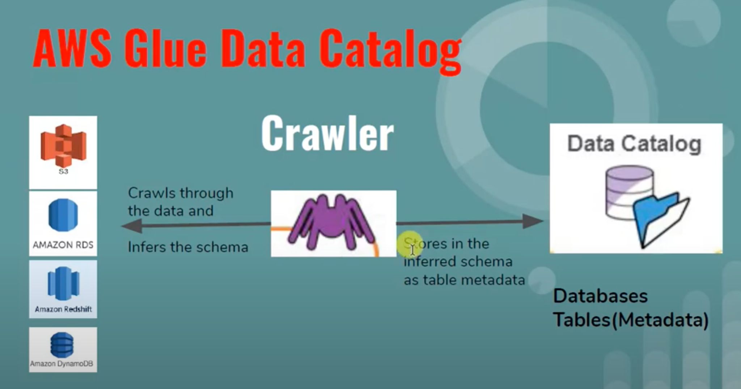

**Store data in s3, create glue crawler which will query your data in s3 and choose how often you want to run the crawler.**

**Create Database and tables in Glue, once they created the database and its tables will popup in Athena, from athena you can query the glue database and table from athena.**

**https://www.youtube.com/watch?v=hPcH9qpq0RE**

**Glue for ETL:**

**https://www.youtube.com/watch?v=z5cd01bV7zk**

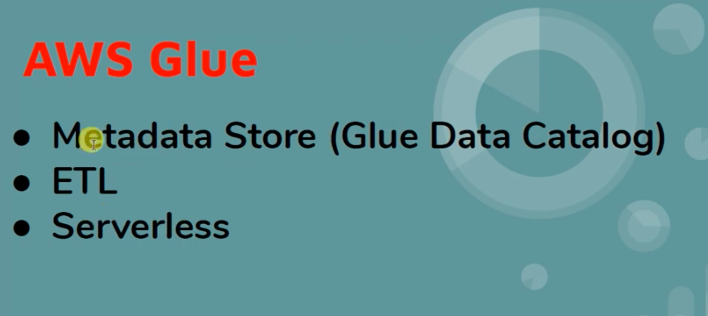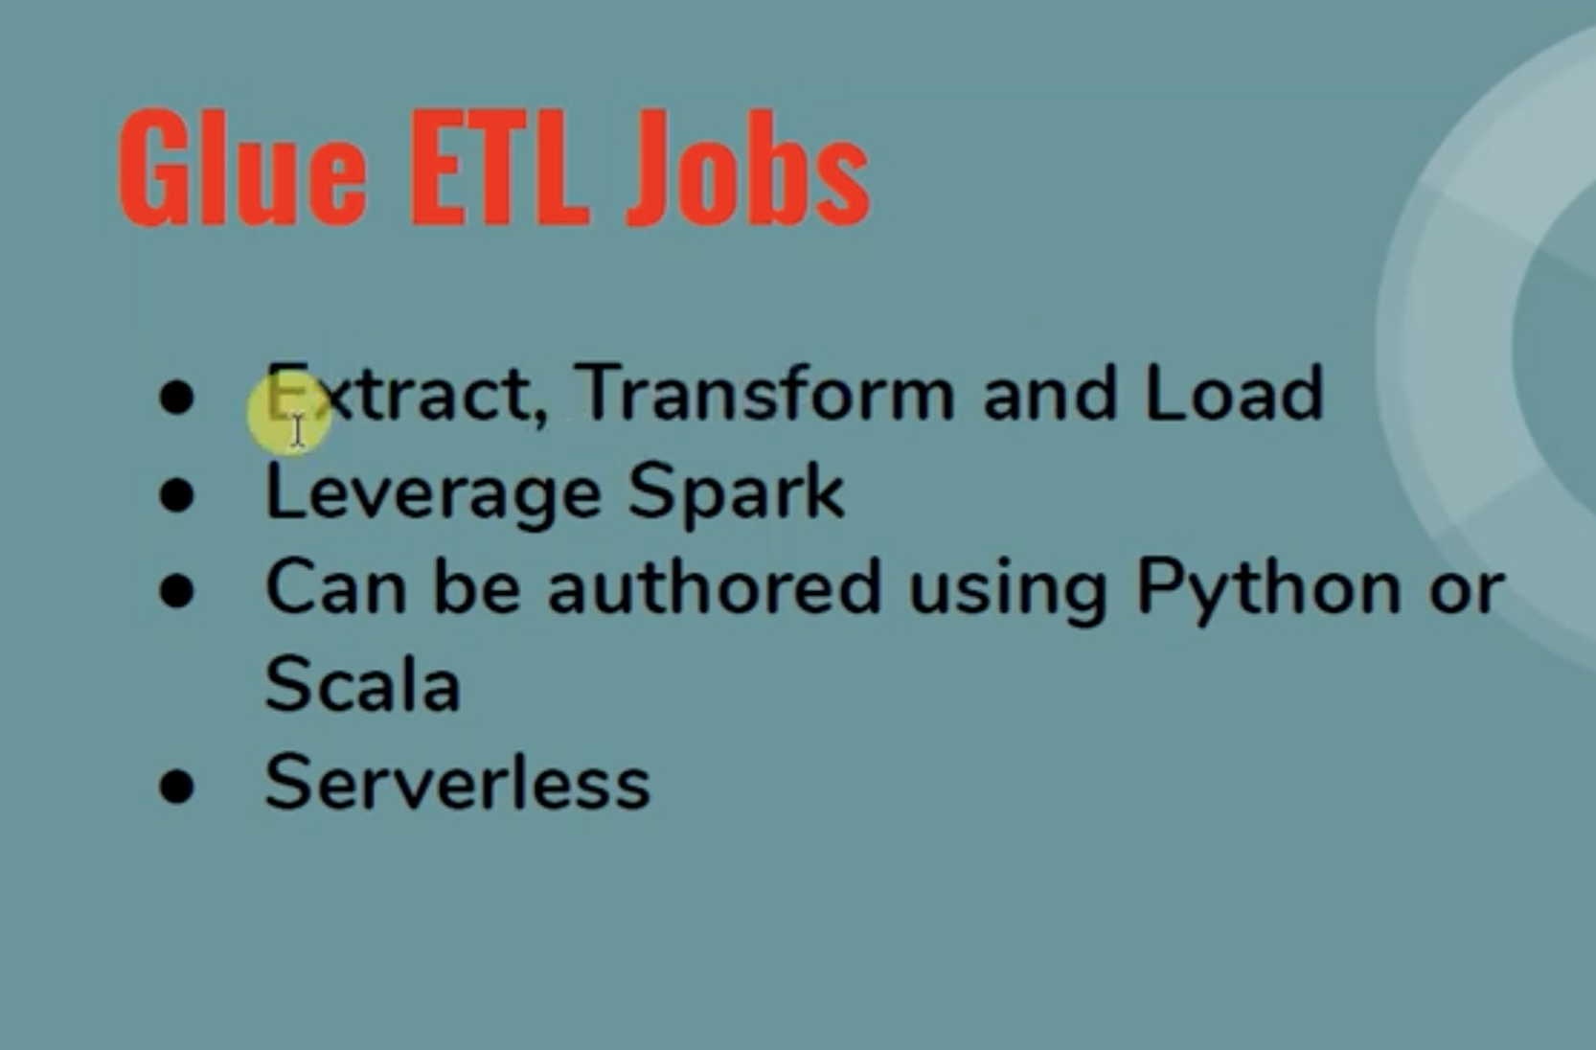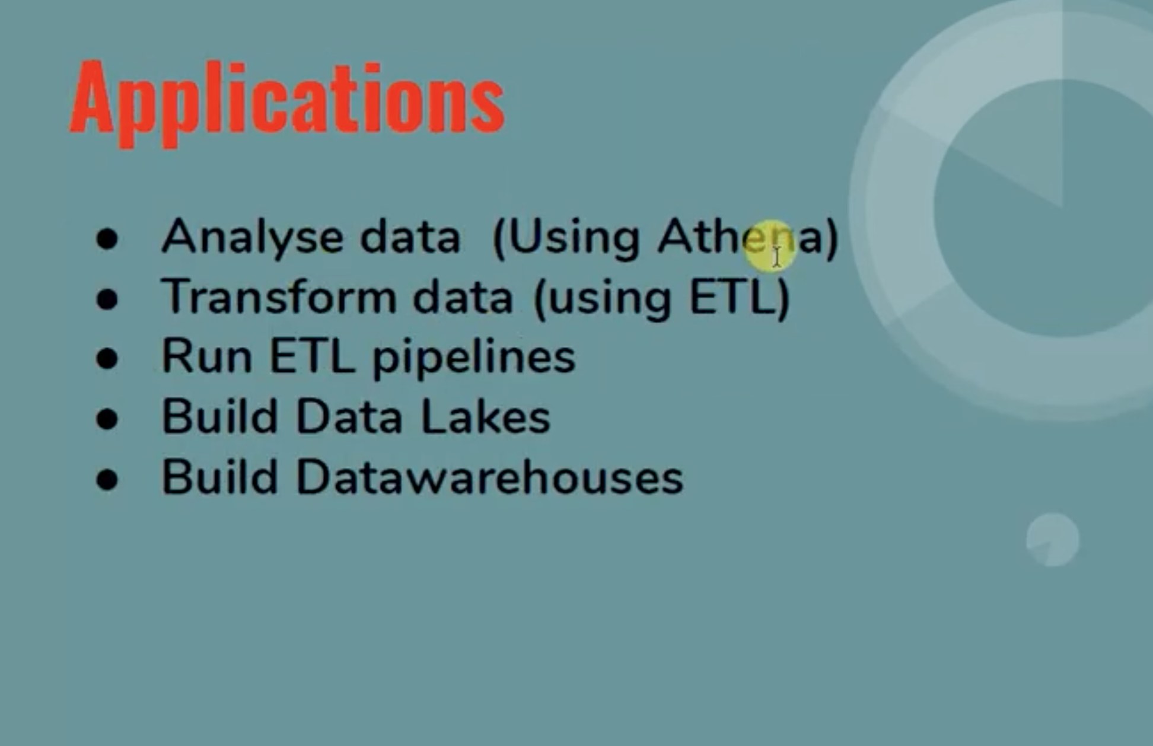

**Glue - https://www.youtube.com/watch?v=dQnRP6X8QAU**

**Glue can have metadata of data in s3 in the format fo table,but it only contains the metadata of the data like database , table and datatype info, using this info you can query the data in athena from glue database and its tables.**

**Glue vs EMR ?**

**-------------------------------------------------------------------------------------------------------------------------------**

**Data services in aws:**

**https://www.youtube.com/watch?v=tykcCf-Zz1Mhttps://www.youtube.com/watch?v=tykcCf-Zz1M**

**-------------------------------------------------------------------------------------------------------------------------------**

# Aws cloudwatch:

**RUM:**

**Synthetic canaries:**

**Lambda PowerTools:**

**-------------------------------------------------------------------------------------------------------------------------------**

**Observability:**

**Fluentbit:**

**https://youtu.be/B2IS-XS-cc0?si=kiGXHPGrsyF_KUz6**

**FluentD:**

**https://youtu.be/5ofsNyHZwWE?si=XH8OPJhNLe-P_agF**

**Ship eks fargate logs to with fluent bit to cloudwatch:**

**https://aws.amazon.com/blogs/containers/fluent-bit-for-amazon-eks-on-aws-fargate-is-here/**

**-------------------------------------------------------------------------------------------------------------------------------**

# Application networking & Fundamentals:

**Service discovery & service networking:** [**https://youtu.be/FswkQ8YfZyc?si=sog_Yz69FgLR0TJq**](https://youtu.be/FswkQ8YfZyc?si=sog_Yz69FgLR0TJq)

**Full Stack observability and monitoring:**

**https://youtu.be/or7uFFyHIX0?si=QU0SzVii5AuXopGF**

**Monitor application across the accounts:**

**https://youtu.be/kFGOkywu-rw?si=DBq4nQrt8kPUZpJ7**

**-------------------------------------------------------------------------------------------------------------------------------**

# Cognito:

**Difference between the cognito user pools and identity pools:** https://repost.aws/knowledge-center/cognito-user-pools-identity-pools

User pools are for [authentication](https://docs.aws.amazon.com/cognito/latest/developerguide/authentication.html). Your app users can sign in through the user pool, or federate through a third-party identity provider (IdP). Identity pools are for authorization. You can use identity pools to create unique identities for users, and give them access to other AWS services.

## Resolution

### User pool use cases

Use a user pool in the following scenarios:

* [Design sign-up and sign-in webpages for your app](https://repost.aws/knowledge-center/cognito-hosted-web-ui).
* [Access and manage user data](https://docs.aws.amazon.com/cognito/latest/developerguide/user-pool-settings-attributes.html).
* Track your user device, location, and IP address, and [adapt to sign-in requests of different risk levels](https://docs.aws.amazon.com/cognito/latest/developerguide/cognito-user-pool-settings-adaptive-authentication.html).
* Use a [custom authentication flow](https://docs.aws.amazon.com/cognito/latest/developerguide/amazon-cognito-user-pools-authentication-flow.html#amazon-cognito-user-pools-custom-authentication-flow) for your app.

### Identity pool use cases

Use an identity pool in the following scenarios:

* Give your users [access to AWS resources](https://docs.aws.amazon.com/cognito/latest/developerguide/iam-roles.html), such as an Amazon Simple Storage Service (Amazon S3) bucket or an Amazon DynamoDB table.
* Generate temporary [AWS credentials for unauthenticated users](https://docs.aws.amazon.com/cognito/latest/developerguide/switching-identities.html).

For more example use cases, see [Common Amazon Cognito scenarios](https://docs.aws.amazon.com/cognito/latest/developerguide/cognito-scenarios.html).

### To-dos-Cognito:

What is the user pool domain ?

Sync store ?

Where user information is stored in cognito ?

What web application used to use before cognito ?

How to configure social media websites in identity pools for cross application login ?

# Apigateway:

#### Different types API’s:

Http, rest, websocket and edge optimized

Timeout - 29 seconds , time out can be increased - need to explore this.

#### **Apigateway limits -**

#### **Default rate limit** - 10,000 per second account limit

#### **Route-level throttling** - You can also set route-level throttling to override the account-level limits for specific routes or stages in your API. The default route throttling limits cannot exceed the account-level rate limits. You can use the AWS CLI to configure route-level throttling.

#### **Usage Plan-level throttling** - You can also set usage plan-level throttling when you create a usage plan. This allows you to control how fast requests can be submitted for a particular customer. You can configure different values for the rate parameter based on tiers.

#### **Apigate way timeouts** - 15 mins

Api gateway request timeout -29 seconds - this can be increased

#### What is api gateway lambda proxy integration and nonproxy integration ?

#### Apigateway security: api key, cognito or identity pools, lambda authorizer

##### Cache:

##### CORS:

##### Aws Managed and autoscale:

##### 

##### Usage plans:

##### 

##### Resource:

##### Methods:

##### Stages:

##### Deploy:

##### ResourcebasedPolicy:

##### By default not attached with vpc, if needed vpc link can be created and integrated with alb, nlb’

##### How an api key can be integrated with api.

# **Lambda:**

Lambda Environment Variables

Provisioned concurrency

Lambda Cold starts

Lambda Alias

Lambda Version

Lambda Traces

Layers

Lambda Authorizer

Lambda ColdStarts

Lambda Support languages

Lambda logging with cloudwatch and traces with x-ray

# Types of concurrencies that lambda support ?

**AWS Lambda** supports several types of concurrency, which refer to the number of function executions that can occur simultaneously within a given time period. Understanding Lambda concurrency is essential for managing and scaling serverless applications effectively. Below are the different types of concurrency that AWS Lambda supports:

### **1. Reserved Concurrency**

Reserved concurrency refers to a specific number of concurrent executions that you can allocate for a specific Lambda function. When you set a reserved concurrency for a Lambda function, AWS ensures that the function will always have access to that amount of concurrency, even when other functions are being invoked. This can help avoid contention for resources and ensure that the function has the required concurrency capacity.

* **Use Cases**:
  + Preventing other functions from consuming resources needed by a critical function.
  + Ensuring that certain functions can scale independently without being throttled by other workloads.
* **How it Works**:
  + You can specify a reserved concurrency value when you configure the Lambda function.
  + For example, if you reserve 100 concurrent executions for a function, only that function can use those 100 concurrent executions, and no other functions can exceed that limit.
  + Reserved concurrency guarantees that your function will always be able to scale up to that limit, regardless of the overall account's concurrency usage.
* **Example**:
  + If you reserve 100 concurrent executions for a function, no other function in the AWS account can use more than 100 concurrent executions (unless there’s additional capacity).

### **2. Account-Level Concurrency Limit**

This is the total number of concurrent executions allowed across **all** Lambda functions in an AWS account in a given region. AWS imposes an **account-level concurrency limit** to prevent overuse of resources across all Lambda functions.

* **Default Account Limit**:
  + By default, AWS Lambda provides an account-level concurrency limit of **1,000 concurrent executions per region** (this is adjustable upon request).
* **Adjusting the Limit**:
  + You can request an increase to the account-level concurrency limit via the **AWS Support Center** if you need more concurrency capacity.
* **How it Works**:
  + When the combined number of concurrent executions across all Lambda functions exceeds the account-level limit, AWS will start throttling invocations.
  + You can manage this using **reserved concurrency** for individual functions to allocate a portion of the overall account concurrency limit to a specific function.

### **3. Provisioned Concurrency**

Provisioned concurrency allows you to pre-warm a specific number of Lambda instances, ensuring that a function is ready to respond immediately to an event. This helps to reduce the latency that occurs due to the cold start problem.

* **How it Works**:
  + With **Provisioned Concurrency**, AWS will keep a specified number of Lambda instances initialized and ready to execute as soon as an event triggers the function.
  + This avoids the "cold start" latency associated with the Lambda execution environment initialization.
* **Use Cases**:
  + Reducing latency for latency-sensitive applications.
  + Pre-warming instances for functions that need to handle predictable, high traffic.
* **Scaling**:
  + Lambda functions with provisioned concurrency scale automatically based on the specified capacity, without going over the limits of the account or reserved concurrency.
  + For example, if you provision 10 concurrent executions, AWS Lambda will always keep 10 function instances warm, ready to handle requests immediately.
* **Pricing**:
  + You pay for the provisioned concurrency (the number of warm instances) and the compute time your function uses when it is invoked.
* **Example**:
  + If you configure 10 provisioned concurrency units, Lambda will keep 10 instances of your function warm and ready at all times.

### **4. Concurrency for Event Sources**

AWS Lambda’s concurrency can also be influenced by the **event source** invoking the Lambda function. The concurrency model varies for different event sources, such as:

* **Synchronous Event Sources**: These include services like **API Gateway**, **AWS AppSync**, or **AWS Step Functions**. When a synchronous event triggers a Lambda function, the invocations are processed one at a time.
  + For **API Gateway**, for instance, each request triggers a Lambda invocation, and the function's concurrency is limited by the available capacity in the account.
* **Asynchronous Event Sources**: These include services like **S3**, **SNS**, or **CloudWatch Events**. AWS Lambda automatically scales up and down to handle the traffic generated by asynchronous event sources.
  + Asynchronous invocations are generally more flexible, as Lambda will automatically throttle when the function is nearing the concurrency limits or throttling from the event source.
* **Stream-Based Event Sources**: For event sources like **Kinesis** or **DynamoDB Streams**, Lambda automatically scales to process records in the stream. However, the processing concurrency can be limited by the stream's shard limits.
  + For example, if you have **5 Kinesis shards**, Lambda can process up to **5 concurrent executions** at the same time, one per shard. The total concurrency will be determined by the number of shards, with the ability to scale as new records are added.

### **5. Throttling and Automatic Scaling**

Lambda automatically handles scaling based on the volume of incoming requests, but there are certain limits to consider:

* **Throttling**: When the Lambda function exceeds the concurrency limit (either reserved or account-wide), the invocations will be throttled, meaning the requests will be delayed or rejected.
  + For instance, if a function has 1,000 reserved concurrency and there are 1,200 simultaneous requests, 200 requests will be throttled.
* **Automatic Scaling**: Lambda automatically scales to accommodate incoming requests within the limits of the account's concurrency. However, if the concurrency exceeds the available capacity, AWS Lambda will throttle the requests.

### **6. Max Concurrency Per Region**

Each AWS Lambda function can scale to a **maximum concurrency** based on the account-level limit in that region. The maximum concurrency for all Lambda functions in an account is initially set to **1,000 concurrent executions per region**(this can be increased via a request to AWS Support).

* **Example**:
  + If you have 10 Lambda functions running in the same region, and each function uses 100 concurrent executions, the total would be 1,000 concurrent executions.
  + If the limit is increased to 5,000 concurrent executions, the total number of invocations across all functions can scale up accordingly.

### **Summary of Lambda Concurrency Types**

| **Concurrency Type** | **Description** | **Use Case** |
| --- | --- | --- |
| **Reserved Concurrency** | Allocate a fixed number of concurrent executions for a Lambda function. | Ensuring critical functions always have access to a specified number of concurrent executions. |
| **Account-Level Concurrency** | Limit on the total number of concurrent executions for all Lambda functions in an AWS account (region-based). | Preventing overuse of concurrency and throttling across all Lambda functions. |
| **Provisioned Concurrency** | Pre-warming a specified number of Lambda instances for immediate invocations to avoid cold starts. | Reducing latency for latency-sensitive applications, especially for high traffic loads. |
| **Event Source Concurrency** | Concurrency influenced by the event source (Kinesis, S3, SNS, API Gateway, etc.). | Event-driven scaling, particularly for high-throughput event sources (e.g., Kinesis). |
| **Throttling and Automatic Scaling** | Lambda automatically handles scaling and throttling when concurrency limits are exceeded. | Ensuring automatic scaling based on incoming requests and managing concurrency. |

### **Conclusion**

AWS Lambda provides flexibility to control concurrency at different levels, from individual functions (via reserved or provisioned concurrency) to the entire AWS account (via account-level limits). Understanding how each type of concurrency works is important for optimizing performance, managing costs, and ensuring that your Lambda functions meet the performance and scalability needs of your application.

# Athena:

Its an opensource sql query engine

Workgroups

DPU - data processing units

# Glue:

Glue datacatalog

Crawler

Glue dataset

# Backup:

Backup policies in the payer or control tower account

Attach the policies to OU

### Back policy contain:

Supported resource to get backed up aws backup service

Tag/key value to check on the resource

Retention on backup snapshots

How often it will take the backup of resources

### In the member account:

Backup policies pushed or inherited from the parent account can’t be modified in the member accounts.

Create vault, vault key

# EMR & REDSHIFT:

When to use emr and redshift ?

Difference between them ?

What is the architectural difference between them ?

What is the real time use case of these services when used in production applications ?

<https://www.linkedin.com/advice/3/what-key-differences-similarities-between-redshift#:~:text=Redshift%20uses%20a%20relational%20data,where%20complex%20queries%20are%20needed>.

# SageMaker: